**BLOCK DIAGRAM:**

Test Image

Training set images

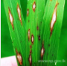

Different Leaf Diseases Images

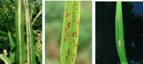

Training Images Features

Segmentation Using K-Means Clustering

Final Classified Result

Preprocessing

Color, Texture and Shape Feature Extraction

Classification using KNN

**Arduino**

**Relay 1**

**Relay 2**

**Relay 3**

**MATLAB (IMAGE PROCESSING)**

**LCD**